**Task 3**

3. How to add markup to JavaScript with JSX

Tasks:

1. Create a component that displays an unordered list (<ul>) of 3 favorite fruits.

**Fruits.jsx**

import React from 'react'

export default function Fruits() {

return (

<>

<ul>

<li>Apple</li>

<li>Orange</li>

<li>Guava</li>

</ul>

</>

)

}

**Main.jsx**

import Fruits from './Fruits.jsx'

createRoot(document.getElementById('root')).render(

<StrictMode>

<Fruits />

</StrictMode>

)

**Output**

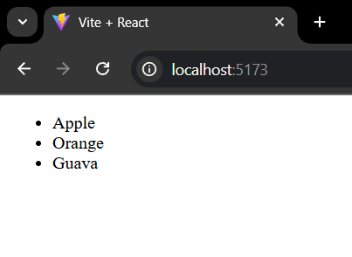

2. Update the above component to display a picture (<img>) of each fruit next to

its name. (Use hardcoded image URLs for now.)

**Fruits.jsx**

import React from 'react'

export default function Fruits() {

return (

<>

<ul>

<li>Apple<img src='https://encrypted-tbn0.gstatic.com/images?q=tbn:ANd9GcRhKuQBuBoYU76-ij4p58VPAVK7CT5uMwOE-A&s'/></li>

<li>Orange<img src='https://encrypted-tbn0.gstatic.com/images?q=tbn:ANd9GcQsmAIUQS96mSvF4M-LdL7h__c0GNCI9Ue0PQ&s'/></li>

<li>Guava<img src='https://encrypted-tbn0.gstatic.com/images?q=tbn:ANd9GcQQlefiYe89UqwHkclZwAlb3bk0nFOOndAQIQ&s'/></li>

</ul>

</>

)

}

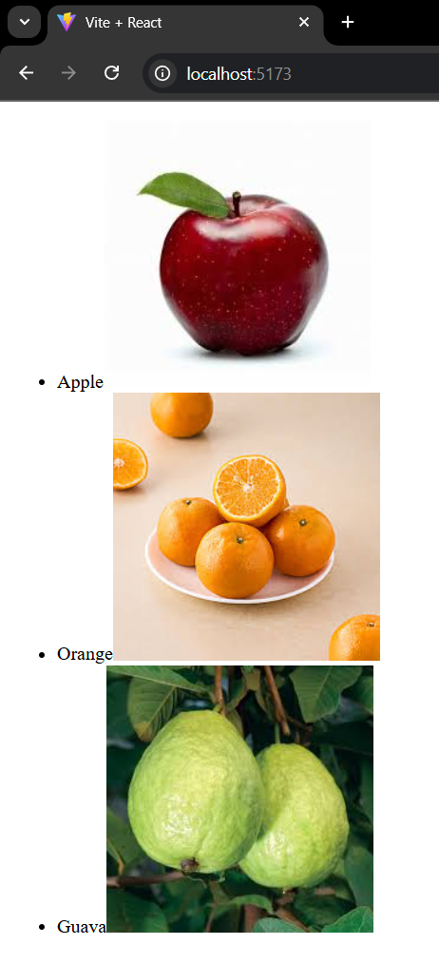

3. Create a component WebsiteLink that displays a hardcoded URL in an anchor

(<a>) tag.

**WebsiteLink.jsx**

import React from 'react'

export default function WebsiteLink () {

return (

<>

<h2>URL is Here</h2>

<a href='https://react.dev/'>Click here!</a>

</>

)

}

**Output**

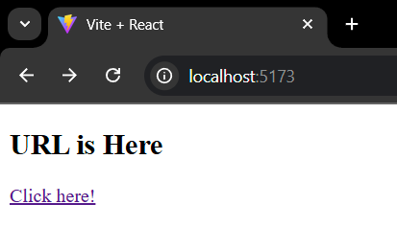

4. Make a JSX component that mimics a simple blog post with a title, content,

and author. (All hardcoded.)

**Blog.jsx**

import React from 'react'

export default function Blog() {

return (

<>

<h1>Learn React</h1>

<p>React is a JavaScript library primarily used for building user interfaces (UIs) for web applications, enabling developers to create dynamic and interactive experiences with reusable components and a virtual DOM for efficient updates</p>

<h3>Author - Kavin</h3>

</>

)

}

**Output**

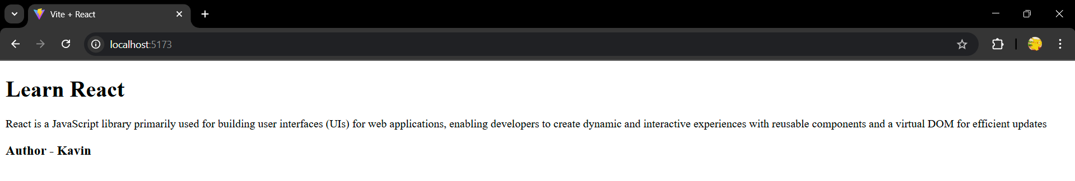

5. Design a Footer component with hardcoded copyright information using JSX.

**Blog.jsx**

import React from 'react'

export default function Blog() {

return (

<>

<h1>Learn React</h1>

<p>React is a JavaScript library primarily used for building user interfaces (UIs) for web applications, enabling developers to create dynamic and interactive experiences with reusable components and a virtual DOM for efficient updates</p>

<h3>Author - Kavin</h3>

<footer>&copy; CopyRights reserved @ 2025 from kavin</footer>

</>

)

}

**Output**

